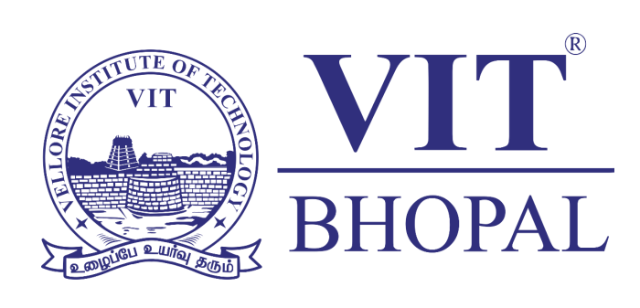

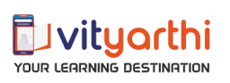

<<<PROJECT REPORT>>>
Submitted By: Aparna Pandey
Course Code: CSE0001
Registration Number: 25BAI10411
Course: Btech CSE(AIML) 1st Year
Institute: VIT Bhopal

TASK 1: Create a Digital Literacy Awareness Infographic

Tools: Canva
Description:
I made a poster about literacy. The poster has a layout with three columns. This makes it easy to understand the information. The poster has three parts: what digital literacy is, a list of tools that students can use to get work done and do research and tips for staying safe online.
One of the things about making the poster was fitting all the information into a small space. I had to take ideas like being safe, on the internet and break them down into small points that students can understand quickly. It was not easy to turn these ideas into a poster that is easy to follow and that will help students use digital literacy.
This project showed me that graphic design is very important when we want to teach people skills, especially skills that are technical. Digital literacy is something that we need to teach people and graphic design can help us do that.

TASKS 2: Build Your Student Digital Portfolio

Tools:
I have used GITHUB, LINKEDIN and KAGGLE AS MY CORE PLATFORMS.
Description:
- Github works as my main platform for version control and collaborative programming, facilitating the documentation of my project's development and the presentation of my code.

- LinkedIn serves as my professional digital portfolio, enabling me to connect with industry mentors, share my progress and participate in professional networks.

- Kaggle constitutes my primary environment for data science and machine learning, it offers access to real-world datasets, complimentary cloud-based coding environments, and competitive challenges that facilitate the transition from theoretical understanding to practical application.
Over the forthcoming four years, I intend to utilize these tools in a systematic manner. Initially, I will concentrate on experiential learning by completing Kaggle tutorials and hosting small-scale academic projects on Github to achieve proficiency in version control.
By my third and fourth years, I will focus on building a strong portfolio by contributing to open-source projects on Github, participating in competitive data science challenges on Kaggle and regularly sharing my milestones on LinkedIn to attract internships and professional opportunities. Integrating these platforms will ensure my academic progress is visible, documented and aligned with industry standards.

TASKS 3: Explore Coding & Collaboration Platforms

Tools:
For this task, I used two digital platforms: HackerRank and Google Workspace (Forms and Sheets).
Description:
On HackerRank, I practiced algorithmic problem solving by implementing leap year logic in Python, which strengthened my understanding of conditional statements and automated testing environments.
Furthermore, I built a "Digital Literacy Awareness Quiz" using Google Forms to assess cybersecurity knowledge among my peers, linking the results to Google Sheets for streamlined data management.
These tools are highly beneficial to my academic career. HackerRank provides a rigorous environment to sharpen technical skills required for computer science coursework and future professional assessments. Meanwhile, mastering Google Workspace tools allows me to conduct research, collect data efficiently and present findings in an organized manner. By integrating technical coding practice with data collection and literacy outreach, I am developing a well-rounded digital skillset. This dual approach ensures I can not only build complex software but also navigate the broader digital landscape securely and collaboratively, essential competencies for any modern student.

TASKS 4: Draft a Professional Email & Etiquette Guide

A clear example of poor digital communication is the "reply-all" email disaster. Imagine a manager sending a sensitive project update to a large team, only for a disgruntled employee to "reply-all" with an unprofessional, frustrated critique of the management. This instantly broadcasts negativity to everyone, including senior leadership, destroying team morale and damaging the employee's reputation. The issue here is the misuse of digital tools, what should have been a private conversation was turned into a public spectacle due to a lack of situational awareness and impulse control.
To handle this differently, the employee should have requested a private one-on-one meeting with the manager to express their concerns constructively. Furthermore, implementing read-before-sending policies and utilizing collaborative project management platforms, like those highlighted in the poster, such as Notion or Trello, would keep feedback channels focused and private, preventing unnecessary conflict and maintaining a professional environment.

Tasks 5: Cybercrime Awareness Case Study & Prevention Guide

What surprised me most during this research was the psychological sophistication of social engineering. I previously assumed that digital theft was primarily about high-tech hacking however, the "QR Code Refund" trap proves that scammers often exploit simple human psychology, like the urgency of a "pending refund,” to trick victims into compromising themselves. Discovering that a PIN is never required to receive money was a significant moment, it is a simple rule, yet its misunderstanding leads to thousands of people losing their savings in seconds.
As a result of this project, the one habit I will personally change is my approach to multifactor authentication. While I used to rely on basic SMS codes, learning about the rising threat of "SIM swapping" has convinced me to switch to an authenticator app like Google Authenticator. I will also be performing a permissions audit on my mobile apps to ensure that none have unnecessary access to my contacts or camera.

